CS 255 System Design Document Template
Isaac Baek

UML Diagrams

UML Use Case Diagram
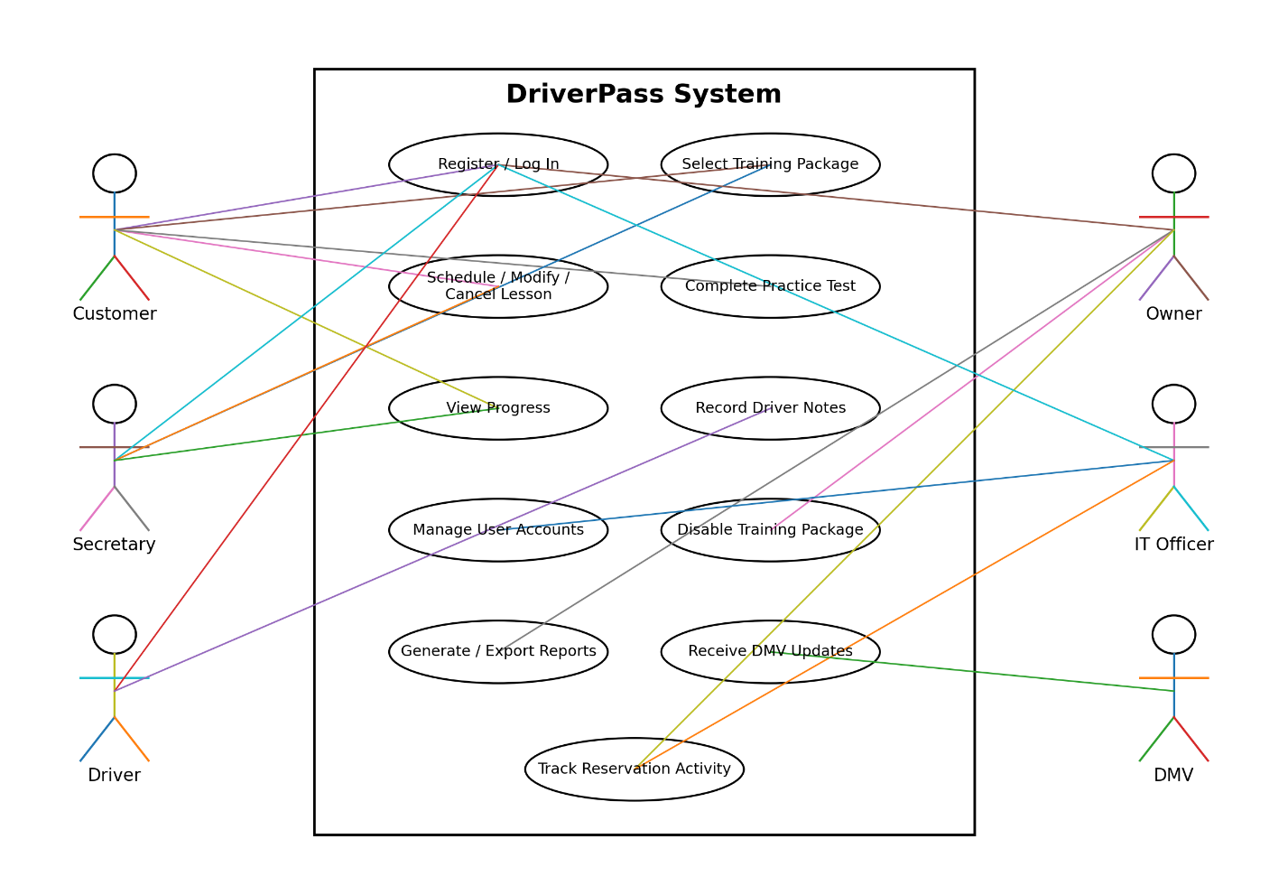
The use case diagram represents the main users of the DriverPass system and the functions available to each user. The Customer can register or log in, select a training package, schedule or modify driving lessons, complete practice tests, and view progress. The Secretary can register customers, select packages for customers, schedule or modify lessons, and view customer information. Drivers can access the system and record notes about completed driving lessons.

The Owner can review reports, disable training packages, and review reservation activity. The IT Officer can manage user accounts and review system activity. The DMV is represented as an external system because DriverPass needs to receive updated rules, policies, and practice questions. These functions reflect the needs described during the DriverPass interview, including different employee roles, appointment management, online training, reporting, and DMV updates.

UML Activity Diagrams
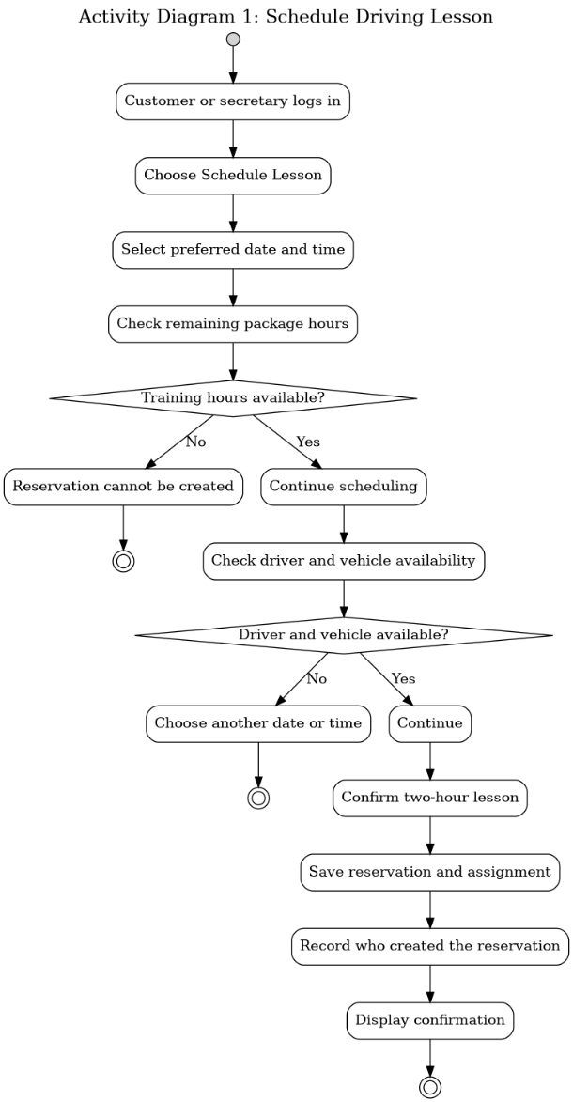
This activity diagram shows the steps involved when a customer or secretary schedules a driving lesson. The user first logs in and chooses to schedule a lesson. After selecting a preferred date and time, the system checks whether the customer has enough remaining driving hours in the selected training package.

If training hours are available, the system checks whether a driver and vehicle are available at the requested time. If either is unavailable, another time must be selected. When all requirements are met, the system confirms the two-hour lesson, saves the reservation, records who created it, and displays a confirmation. This process meets DriverPass's requirement to coordinate the customer, driver, vehicle, date, and time for every lesson and helps prevent scheduling conflicts.
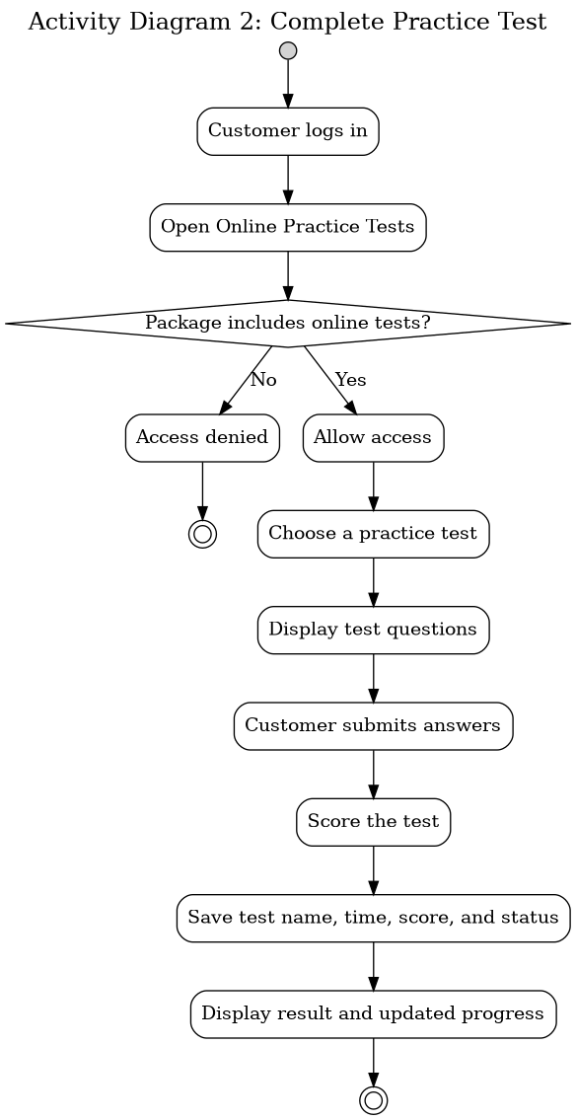
This activity diagram shows how a customer completes an online practice test. After logging in, the customer opens the practice test area. The system checks whether the customer's selected training package includes access to online testing. If access is available, the customer selects a test, answers the questions, and submits the test.

The system then scores the test and saves the test name, time taken, score, and status. The result is displayed to the customer and added to the customer's progress information. This supports DriverPass's goal of giving students access to current practice materials and allowing them to monitor their preparation for the driving exam.

UML Sequence Diagram
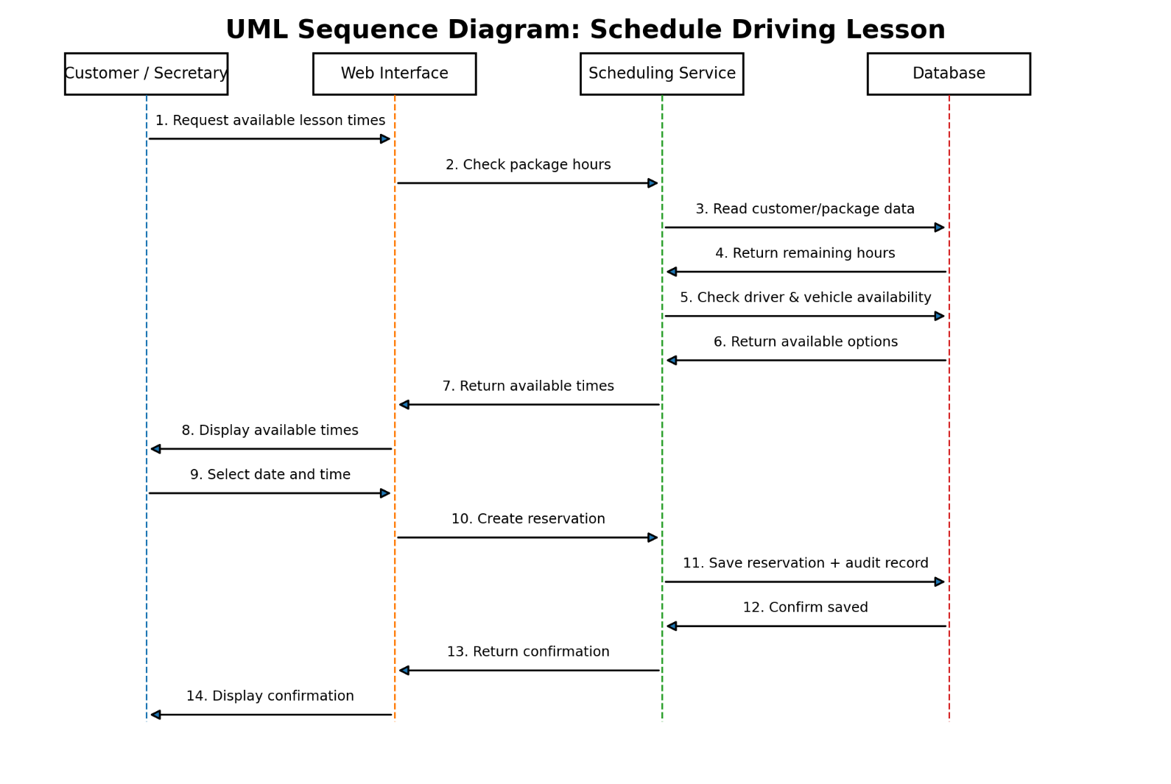
The sequence diagram expands on the Schedule Driving Lesson use case. It shows communication between the Customer or Secretary, the Web Interface, the Scheduling Service, and the Database.

The process begins when the user requests available lesson times. The system checks the customer's remaining package hours and retrieves the required information from the database. It then checks driver and vehicle availability. Available times are returned to the user, who selects a date and time. The system creates the reservation, stores it in the database, records the activity for tracking purposes, and returns a confirmation to the user.

This sequence supports DriverPass's need to ensure that appointments are based on remaining training hours while also matching each customer with an available driver and vehicle.

UML Class Diagram
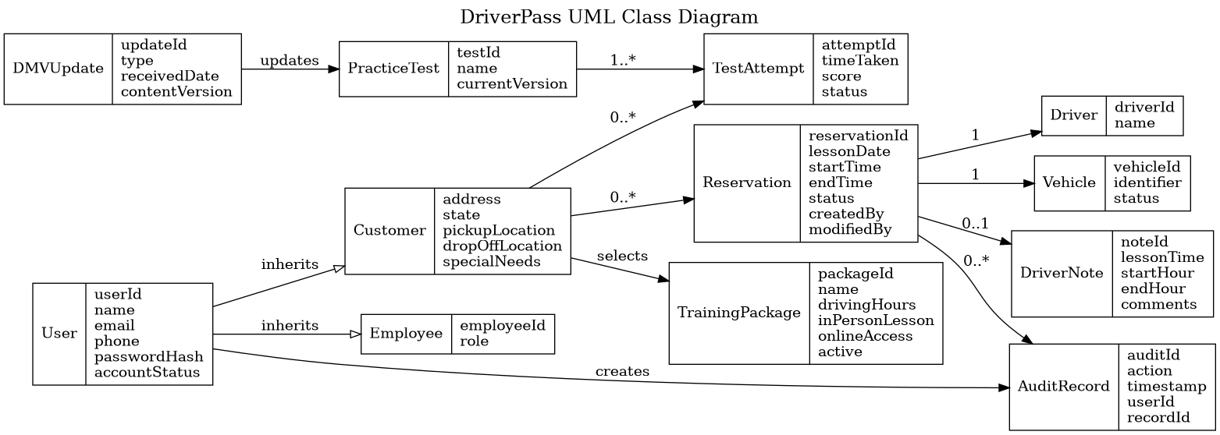
The class diagram identifies the major classes and attributes required by the DriverPass system. The User class contains shared account information such as user identification, name, email address, phone number, password information, and account status. Customer and Employee represent more specific types of users.

The Customer class stores information such as address, state, pickup location, drop-off location, and special needs. The TrainingPackage class stores the package name, number of driving hours, whether an in-person lesson or online access is included, and whether the package is currently active.
The Reservation class contains the lesson date, start time, end time, status, and information about who created or modified the reservation. Reservations are associated with a Driver and Vehicle so that DriverPass can track which customer is assigned to which driver and car.

PracticeTest and TestAttempt represent online testing and customer results. TestAttempt includes the time taken, score, and status. DriverNote stores lesson information and driver comments. DMVUpdate represents updated rules, policies, and testing information received from the DMV. AuditRecord stores important changes made in the system so DriverPass can determine who performed an action and when it occurred.

These classes support the major business needs identified in the interview, including customer information, packages, lesson scheduling, testing, driver notes, DMV updates, and activity tracking.

Technical Requirements
Hardware Requirements
- DriverPass employees will need computers or mobile devices capable of running a modern web browser.
- Customers will need an internet-connected computer, tablet, or smartphone to use the online system.
- DriverPass will not require an on-site application server because the system will be hosted in the cloud.
- Cloud-hosted server resources will be required to run the web application and database.
- Reliable internet access will be required for creating, modifying, or retrieving current system records.
- Appropriate backup storage will be required through the selected cloud-hosting provider.
Software Requirements
- The DriverPass system will operate as a web-based application.
- The system must support current browsers on Windows, macOS, Android, and iOS devices.
- A server-side application will be required to process business rules related to authentication, training packages, scheduling, testing, reporting, and user permissions.
- A relational database management system will be required to store customer records, employee accounts, training packages, reservations, vehicles, drivers, test results, driver notes, and activity records.
- The system will require secure account authentication and password-reset functionality.
- Reporting functionality must allow authorized users to generate printable reports and export selected information for use in applications such as Microsoft Excel.
- The system will require a connection or supported integration method for receiving DMV updates.
Development and Design Tools
- Lucidchart will be used as the CASE tool for creating UML use case, activity, sequence, and class diagrams.
- Development tools should support the creation of a responsive web application that can be used on both computers and mobile devices.
- Database development and administration tools will be needed to create and maintain the centralized system database.
- Testing tools will be required to verify login security, account permissions, scheduling rules, database operations, and web-interface functionality.
Infrastructure Requirements
- The system should use cloud hosting because DriverPass does not want to maintain its own servers, backups, or infrastructure.
- The application and database should be centrally hosted so all users access the same current information.
- Users must be online to create or modify system information. Reports may be downloaded for offline use, but changes to the main system must occur while connected.
- Secure encrypted connections must protect information transmitted between users and the system.
- The cloud environment should provide regular backups and recovery capabilities.
- The infrastructure must support access from multiple users at the same time without creating duplicate or conflicting reservations.
- The system should maintain an activity record showing who created, modified, or canceled reservations.
- Access must be based on user roles so customers, the Secretary, Drivers, the Owner, and the IT Officer only have access to the functions appropriate for their responsibilities.
- The IT Officer must be able to reset accounts and block access when an employee leaves DriverPass or an account becomes compromised.
- The system must support notifications when updated DMV rules, policies, or practice questions become available.

These technical requirements support DriverPass's request for a cloud-based system that can be accessed from computers and mobile devices while providing online testing, driving lesson scheduling, reporting, role-based access, and updated DMV information.

